Sheridan College Drive Multi-Use Path Construction
October 5, 2026
As part of Sheridan's long-term Campus Master Plan, Facilities and Sustainable Infrastructure will be enhancing the north sidewalk along Sheridan College Drive at the Davis Campus by converting it into a multi-use pathway.
Construction is scheduled to begin October 5, 2026, between 8 a.m. and 4 p.m., and will continue through November 2026.
Project overview
This project will widen and enhance approximately 180 metres of the existing sidewalk to create a dedicated multi-use path for cyclists and pedestrians. The pathway will provide a safer connection to campus by separating cycling traffic from bus routes and other vehicles.
Construction activities will include the installation of the new multi-use pathway along the north side of Sheridan College Drive.
What this means
During construction, the north sidewalk along Sheridan College Drive will be temporarily unavailable.
For the safety of our campus community, the construction area will be fully fenced throughout the duration of the project. Staff, students, and visitors are encouraged to use the south sidewalk along Sheridan College Drive. Clearly marked alternative pedestrian and accessible routes will be provided.
Access and safety
Restricted access: For safety reasons, the construction site will remain closed to all staff, students, and visitors throughout the project.
Pedestrian detours: Alternative routes will be clearly identified to help maintain safe access around the work area.
Construction activity: While every effort will be made to minimize disruptions, construction-related noise and activity may be noticeable in the surrounding area during working hours.
Work area map
A map showing the construction area and alternative accessible routes is included below.

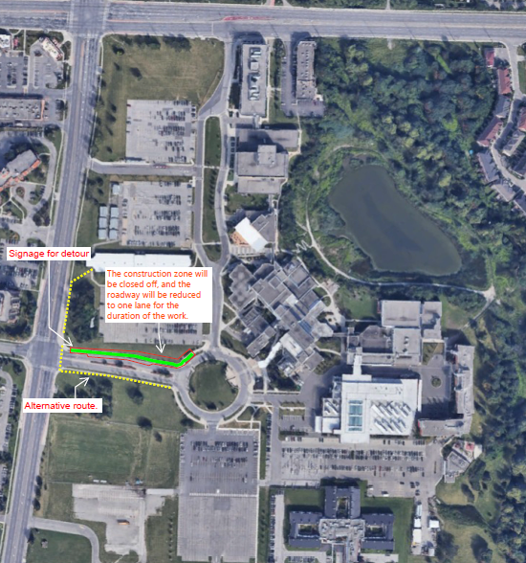

Contact
For more information, questions, or concerns, please contact:
Facilities and Sustainable Infrastructure
facilities@sheridancollege.ca
We appreciate your patience and cooperation as we complete these improvements to support a safer and more accessible campus.

