Thursday, July 16, 2026

Project Title: Improve Curb Appeal on Sheridan college Dr
Campus: TRA - Trafalgar Rd. Campus
Contractor: IPAC Paving Ltd
Start Date: Tuesday, July 21, 2026
Anticipated Completion: Monday, August 31, 2026

The Work

Sheridan College is investing in multiple capital improvement projects to upgrade its facilities and infrastructure, and to replace ageing, end-of-life building systems that are critical to ongoing campus operations. These investments will support creating a more resilient physical environment while ensuring the continued reliability, functionality, and longevity of the College's facilities.
As part of this initiative, Sheridan’s Space Management, Design & Construction team (SMD&C) will revitalize and enhance the curb appeal on Sheridan College Drive, between Parking Lot #1 and Parking Lot #2, which, over the time, has deteriorated significantly and is currently in poor condition, with visible wear and damage that negatively impact its appearance, functionality, and the overall first impression of the campus for students, staff, visitors, and external vendors.
The scope of work includes the removal of the existing deteriorated center median and replacement with asphalt, flush with the adjacent roadway, complete with new pavement markings. Additional improvements will include repainting existing crosswalks and speed bumps, replacing damaged and crumbling curbs, installing artificial turf in designated curbside areas to enhance the site's visual appeal, and removing the abandoned parking station and existing barricades to improve both aesthetics and traffic circulation.
Upon completion, the project will significantly enhance the appearance, safety, accessibility, and functionality of this key campus entrance corridor. These improvements will create a more welcoming and visually appealing gateway to the campus, strengthen first impressions for prospective students, visitors, and institutional partners, and reinforce Sheridan College's commitment to providing a safe, accessible, and well-maintained campus environment.

Construction Work Area

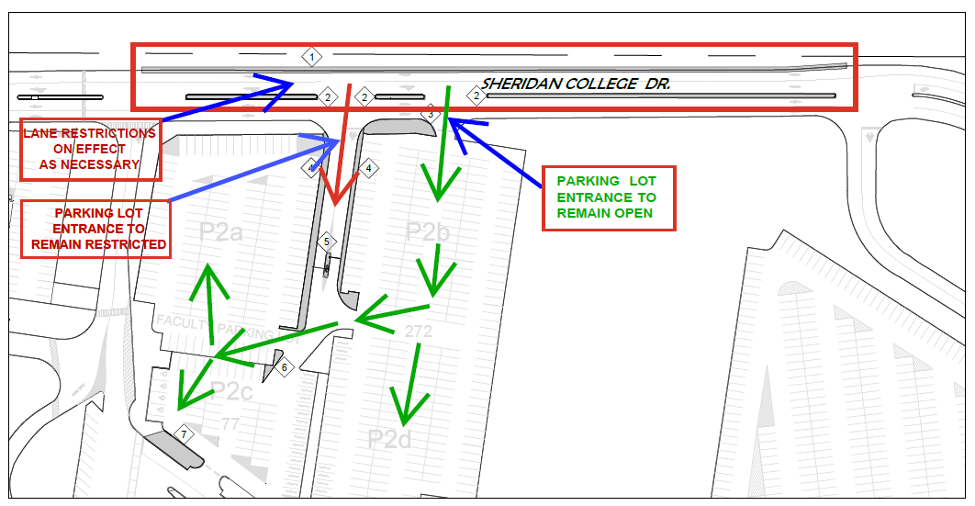

Work Hours

Work is expected to take place between 7:00 a.m. and 7:00 p.m., Monday through Friday. Occasional work outside these hours may be required to accommodate operational or project requirements.

Disruptions

To complete the work safely and efficiently, the following temporary impacts may occur:
- Temporary lane restrictions, including reducing Sheridan College Drive to a single lane, as required.
- Temporary closure of the employee parking entrance providing access to Parking Lots P2a and P2b. An alternate entrance will remain open at all times.
- Intermittent construction noise, dust, and the presence of construction equipment within the work area.
- Temporary pedestrian detours or restricted access adjacent to the construction zone, as required for safety.

Our team looks forward to working with you to allow our contractor to complete this project in a professional and timely manner. Every effort will be made to reduce any inconvenience you may encounter. If you have any questions or concerns, please do not hesitate to contact us.

We look forward to working with you to complete this project in a professional and timely manner. For more information, please contact facilities@sheridancollege.ca or constructionfeedback@sheridancollege.ca.
SMD&C Team:
Project Manager: abhik.misra@sheridancollege.ca
Manager, Capital Projects: lisa.tucker@sheridancollege.ca

