Project Title: Davis B-Wing Heating Plant Refurbishment
Campus: DAV - Davis Campus
Effective Date: Thursday, July 9, 2026

Sheridan is investing in multiple projects to improve campus services by upgrading its facilities and infrastructure in support of a more resilient and accessible physical environment.
As part of this plan, Sheridan’s Space Management, Design & Construction team (SMDC) will be upgrading and enhancing the heating system at the Davis Campus B-wing that supports several buildings and key services. This work is ongoing and planned for completion September 2026 as part of a multi-year approach to support Sheridan’s long-term master plan. Upcoming work is summarized below.
Construction Scope, Timeline and Location:
- Strategic upgrades to the boiler plant and heating system to improve operational and energy efficiency and effectiveness that support numerous functions and spaces that serve teaching and learning, and essential College Services.

- You will notice increased activity and construction personnel near these areas during the months of July and August 2026.

- On July 13, 2026, a crane will mobilize in the B-wing loading dock for one day. This work supports the safe removal of decommissioned equipment from the rooftop. During this time, shipping and receiving services will be temporarily relocated - Signage will be posted locally to redirect the community.

- A map including the work area is included below. Interior corridors and community services will remain open during the construction.

These projects aim to replace end of lifecycle infrastructure vital to ongoing operations and to ensure continued longevity and reliability of our institution’s services.

Every effort will be made to reduce any inconvenience you may encounter. If you have any questions or concerns, please do not hesitate to contact us.

For more information, please contact any of the following:
Facilities - facilities@sheridancollege.ca,
SMDC team:
Nathan Case - nathan.case@sheridancollege.ca,
Chad Mansell - chad.mansell@sheridancollege.ca

Davis Campus B-Wing Area of Work:

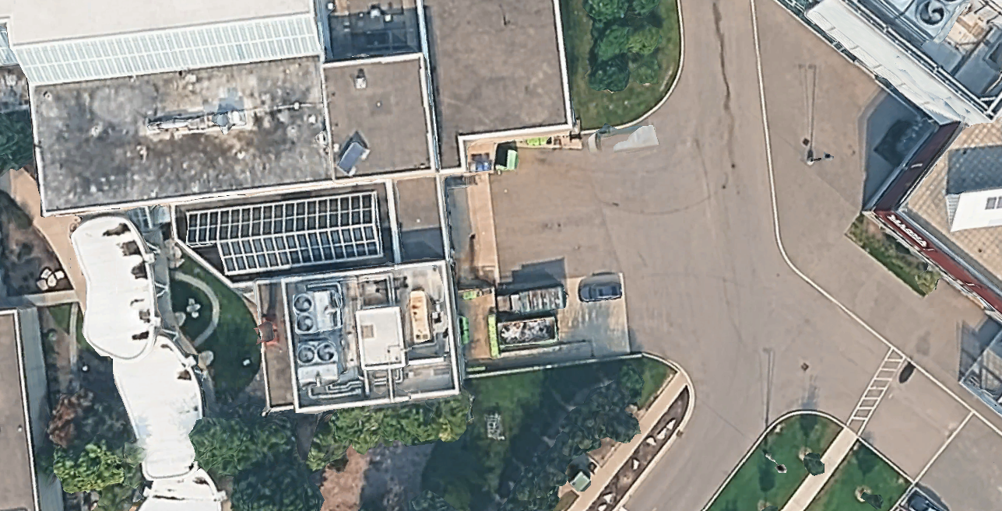
Crane Location

