
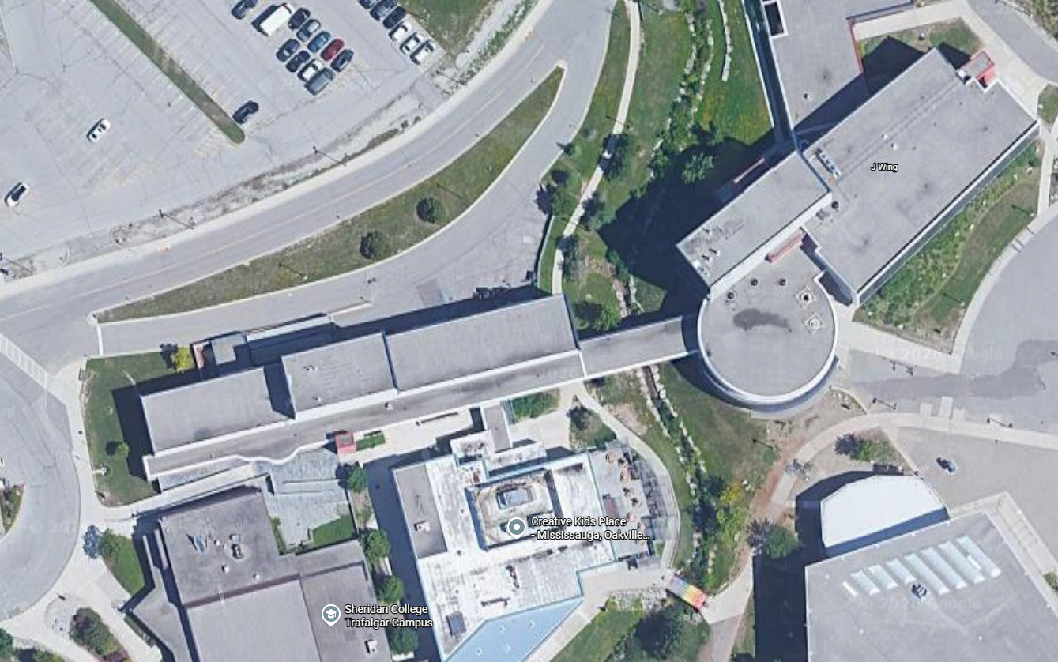
Alternate Stairs ONLY Route out of H-Wing
J-Wing
SCAET
Staff Lot
Lot 2
Student Centre
D-Wing
H-Wing
Accessible Route in/out of H-Wing
H-Wing Ramp (Closed)

