Notice: UPS Replacement at Trafalgar Campus (Saturday, May 02, 2026)
Sheridan’s Space Management, Design & Construction team (SMD&C) will be upgrading the existing UPS units along with batteries and ancillary equipment in the Data Center at Trafalgar E109 as the existing UPS units and batteries are nearing the end of their serviceable life and no longer provide sufficient capacity to protect Sheridan’s critical IT infrastructure during a prolonged power outage. Upgrading this equipment is essential to ensure the long-term reliability and stability of the Data Centre’s power systems, which support many of the college’s core digital services. Following the successful completion of Phase 1 of this work in March to replace the UPS Unit #1, Phase 2 for the replacement of the UPS Unit #2 was postponed due to some unavoidable issues and is now scheduled to proceed.
Work Hours
The outstanding Phase 2 of this work, originally scheduled for March 28, has been rescheduled to be conducted on
- Saturday, May 02 - Replacement of UPS Unit #2; Time: 7:00 AM – 7:00 PM
What’s Happening?
- Scope: The existing UPS units along with batteries and ancillary equipment in the Data Center at Trafalgar, E109 will be replaced.
- Disruption: Please note that during this time, there will be no network service in E-wing and access to certain IT systems and services will be temporarily unavailable, and users should expect a planned outage period for the scheduled removal of old UPS unit/s, installation, start-up, and commissioning of new UPS.
Map of Work Area.
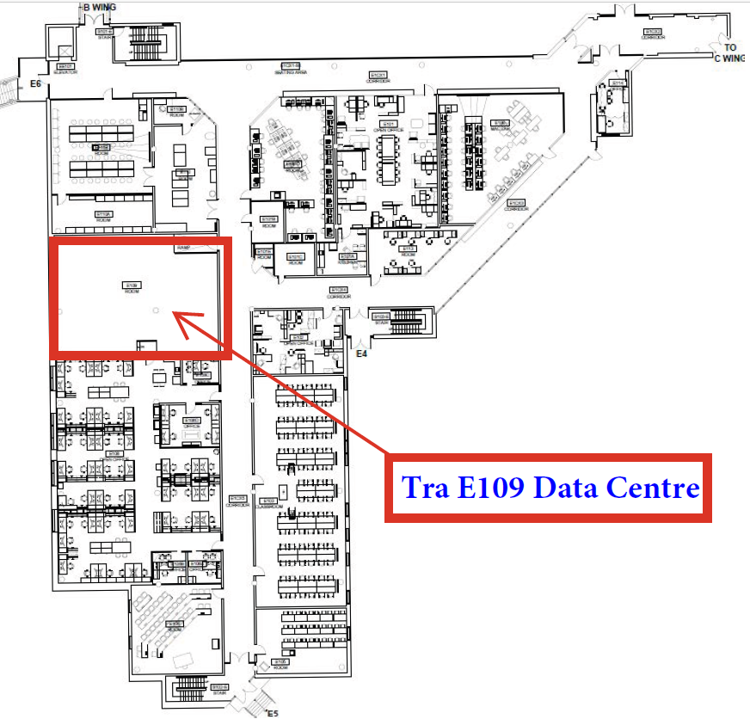
Our team looks forward to working with you to allow our contractor to complete this project in a professional and timely manner. Every effort will be made to reduce any inconvenience you may encounter. If you have any questions or concerns, please do not hesitate to contact us.
We look forward to working with you to complete this project in a professional and timely manner. For more info, please contact facilities@sheridancollege.ca or constructionfeedback@sheridancollege.ca.

