Project Title: Trafalgar Footbridge Replacement
Campus: TRA - Trafalgar Rd. Campus
Effective Date: Thursday, October 23, 2025

Sheridan continues to invest in projects that enhance campus connectivity, safety, and accessibility through upgrades to its facilities and infrastructure in support of a more resilient and inclusive physical environment.
As part of this plan, Sheridan’s Space Management, Design & Construction team (SMDC) will be replacing two existing pedestrian footbridges at the Trafalgar Campus. These bridges have reached the end of their service life and require replacement to ensure continued safety, accessibility, and reliability for campus users.

Construction Scope, Timeline and Location:
- The two existing pedestrian footbridges that connect key campus buildings are currently closed for safety reasons. These bridges will be removed and replaced with new prefabricated structures to ensure continued safety and accessibility. The bridge areas will remain fenced until the new bridges are fully installed.

- Demolition work will take place on October 23rd to minimize disruption to campus activities. The new prefabricated bridges are being constructed off-site. Once fabrication is complete, they will be delivered to campus for installation in November, reducing on-site concrete and heavy construction activities.

- Maps illustrating the work area and alternate routes are provided below.

These improvements address aging infrastructure that is essential to campus operations and will help ensure the continued safety, longevity, and reliability of Sheridan’s built environment.

Every effort will be made to reduce any inconvenience you may encounter. If you have any questions or concerns, please do not hesitate to contact us.

For more information, please contact any of the following:
Facilities - facilities@sheridancollege.ca,
SMDC team:
Lena Javidiani - Lena.Javidiani@sheridancollege.ca
Nathan Case - Nathan.Case@sheridancollege.ca,
Lorie Banhaon - Lorie.Banhaon@sheridancollege.ca

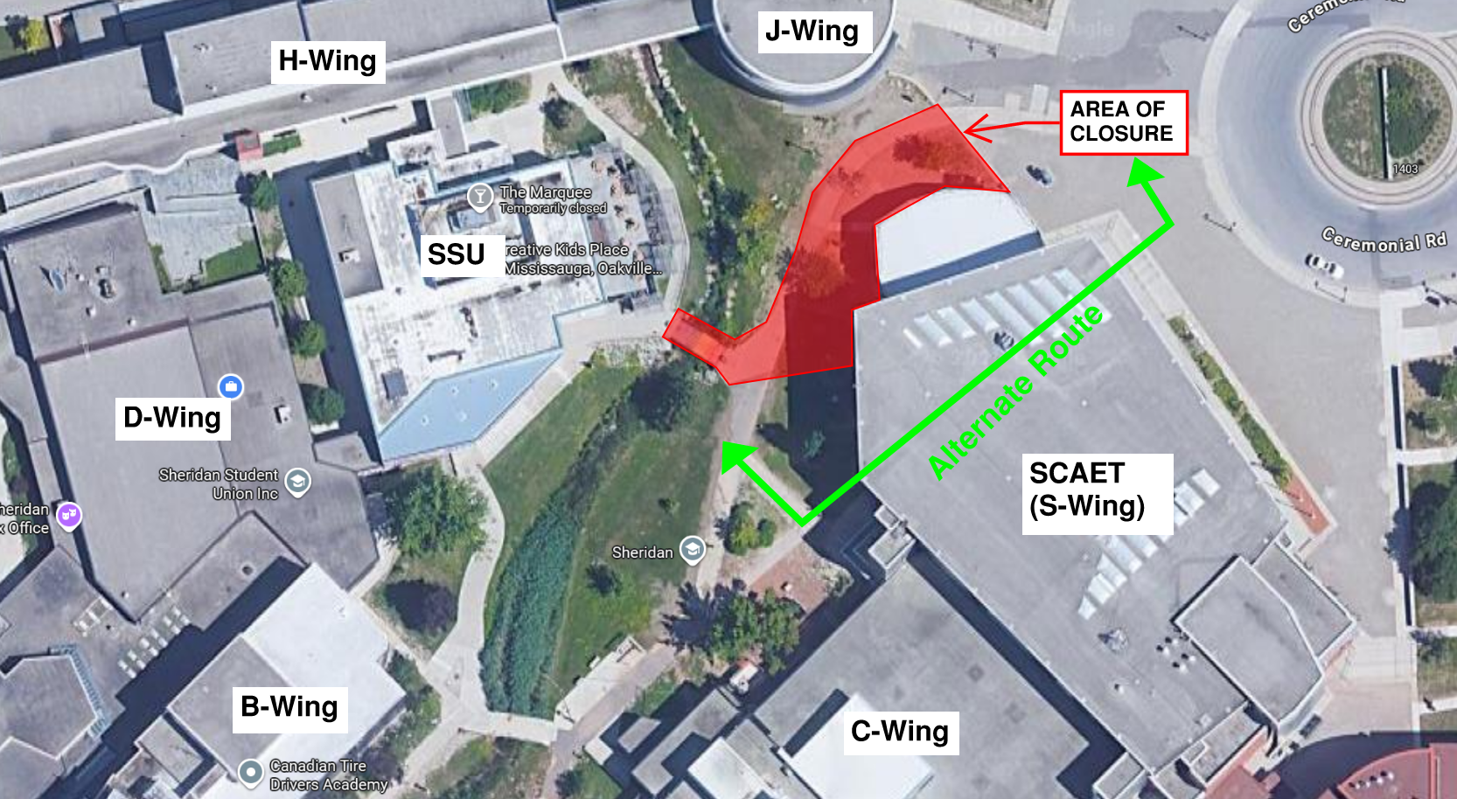
From Creek side to Ceremonial Road:
- Enter SCAET via lower level
- Proceed left and up the bleacher stairs
- Proceed straight, exiting through the SCAET main entrance at street level
*Vice Versa if coming from Ceremonial

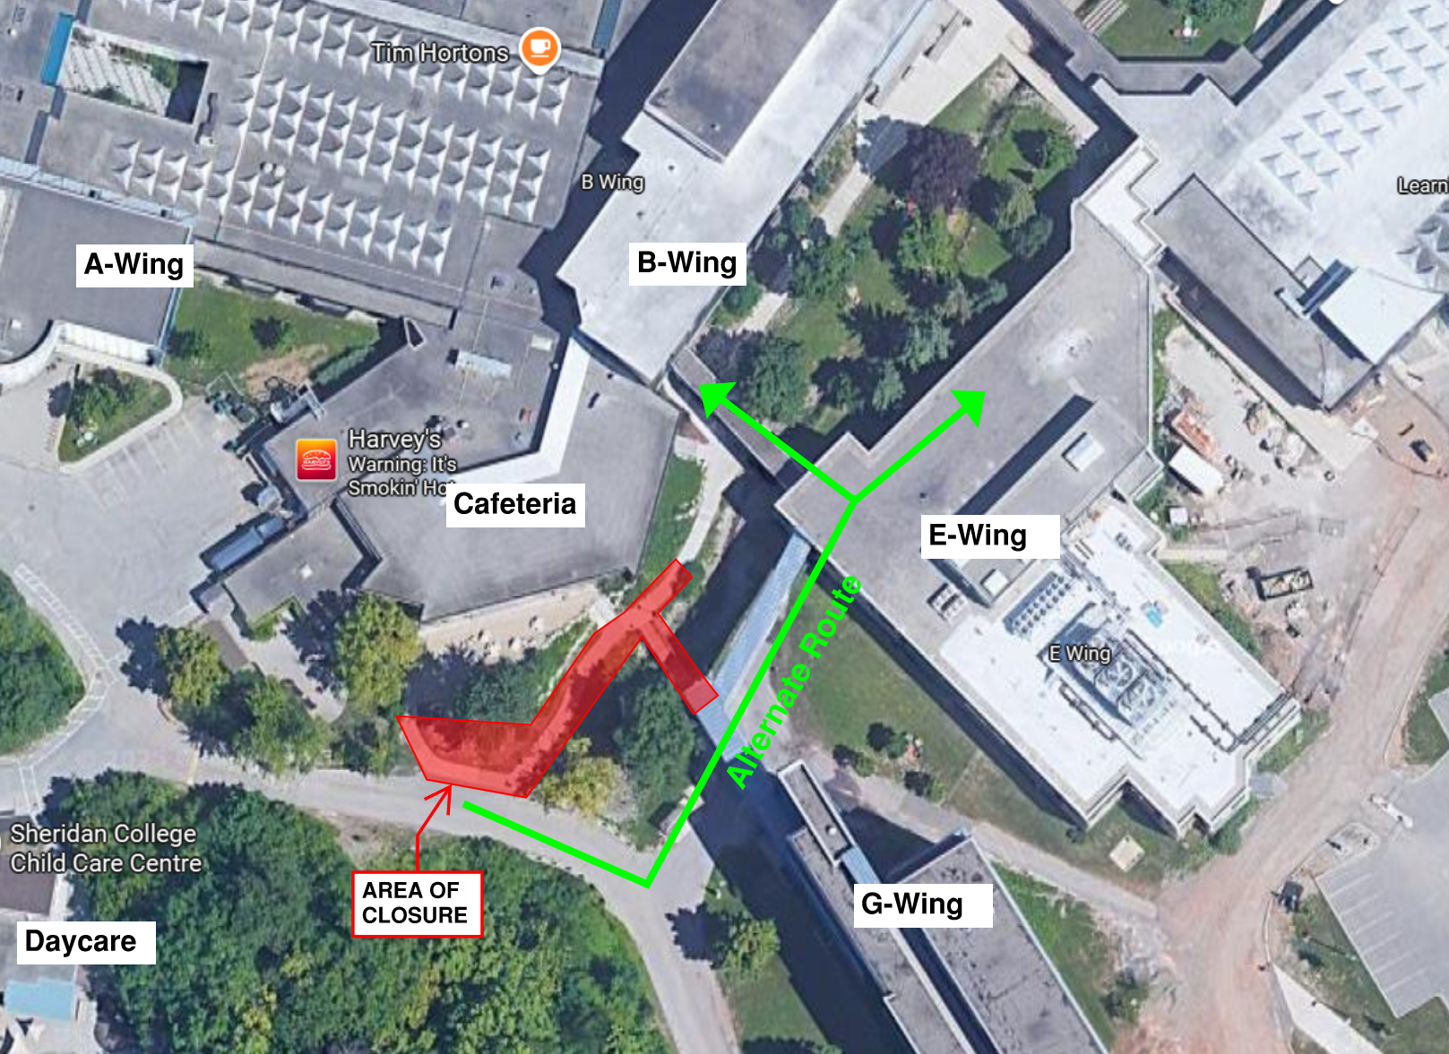
From Cafeteria/G-Wing going towards B and C-Wing:
- Enter E-Wing first floor
- For B-wing; turn left and cross the bridge OR
- For through traffic, proceed straight through E-Wing first floor and exit left towards the creek at C-wing exit doors.
*Vice Versa if coming from B-Wing

