Wednesday, April 16, 2025

Project Title: Trafalgar Daycare Fencing Upgrade

Campus: TRA - Trafalgar Rd. Campus

Contractor: King Fence, Melrose Paving, Fortco and BV Contracting

Start Date: Monday, April 21, 2025

Anticipated Completion: Friday, May 23, 2025

## The Work

Sheridan Facilities and Sustainable Infrastructure (FSI) will be performing upgrades to the Day Care Centre by replacing the existing fencing system and asphalt in support of a more safe, private, and improved environment. Construction work will commence on **Monday April 21st, 2025** and is expected to be completed by **Friday May 23rd, 2025**. Your co-operation and patience during the construction period is crucial and appreciated.

## Map of Work Area

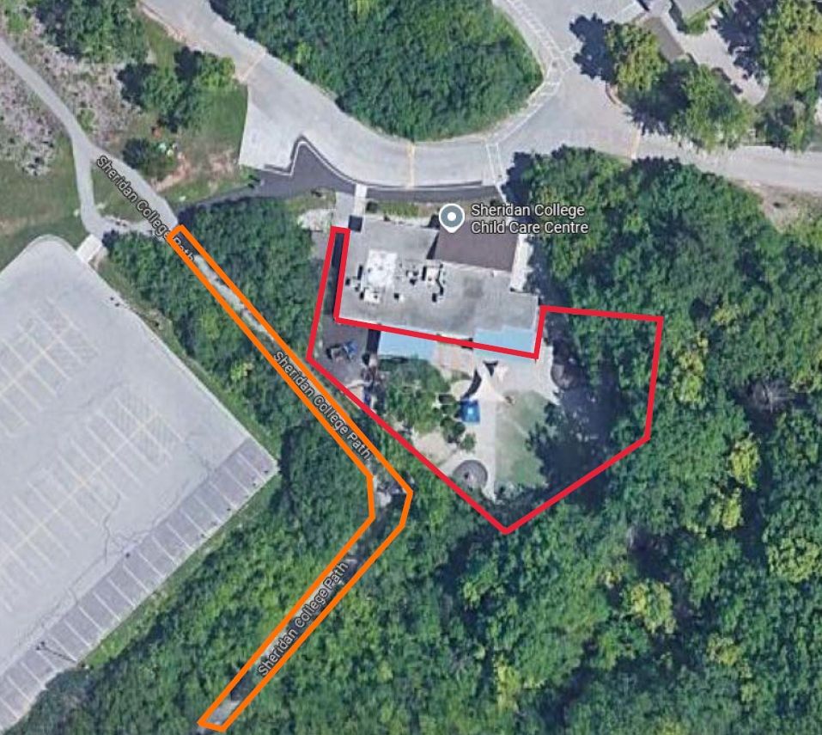

## 

## Work Hours

## Work will take place between 7:00am to 5:00pm from April 21st to May 23rd, 2025.

## Disruptions

In order to complete the work effectively and in a safe manner, some restrictions will be necessary, including:

* Temporary closure of the playground at the Daycare Centre
* Temporary closure of the pathway behind the Daycare Centre

Sheridan College Facilities Projects looks forward to working with you to allow our Contractor to complete this project in a professional and timely manner. Every effort will be made to reduce any inconvenience you may encounter.

For more information please contact [constructionfeedback@sheridancollege.ca](mailto:constructionfeedback@sheridancollege.ca)