Friday, April 11, 2025

Activity: Davis Water Shutdown
Project Title: DAV FSI Water Backflow Preventers
Campus: DAV - Davis Campus
Contractor: Active Mechanical
Start Date: Wednesday, April 16, 2025
Water Shutdown Date: Saturday, April 19, 2025 (College will be closed on this day)
Anticipated Completion: Saturday, April 26, 2025

The Work

Sheridan Facilities and Sustainable Infrastructure (FSI) is conducting the installation of: (x2) two curb stop water valves for domestic water & fire water incoming supply lines which requires a complete water shutdown of incoming water main supply from the city in entire Davis campus and also (x2) two backflow preventers for domestic water and fire water incoming supply lines as per Region of Peel - Safe Drinking Water Act in Davis B-wing. The construction area is indicated in the map below where (x2) curb stops are marked up in both sides of B-wing main entrance and the buildings that are going to be affected by the water shutdown are highlighted. Your co-operation and patience during the construction period is crucial and appreciated.

Map of Work Area

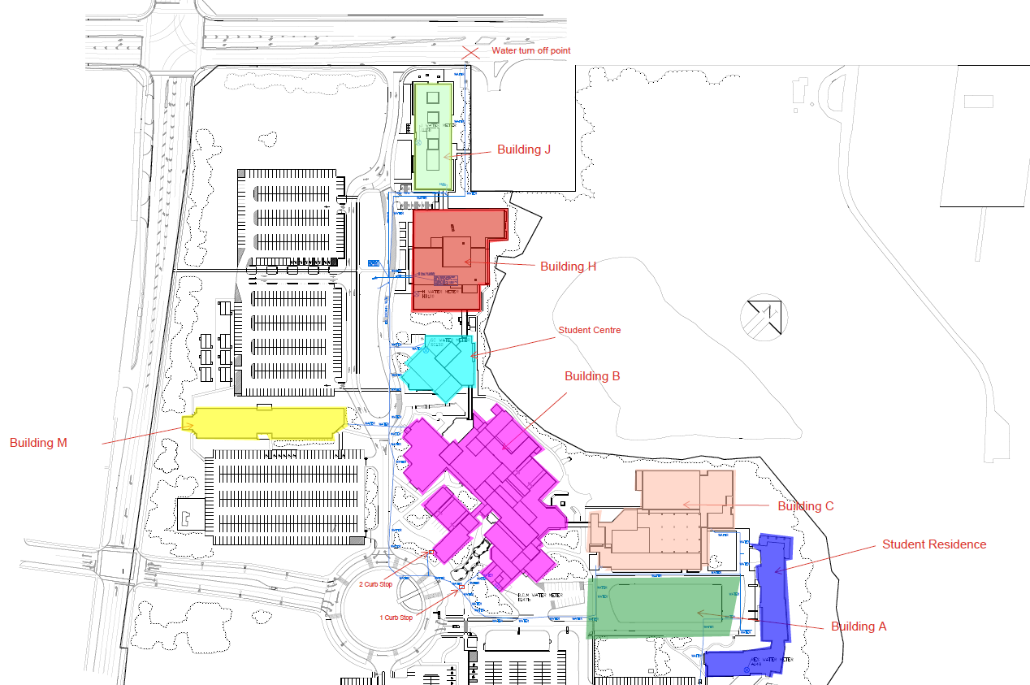

Work Hours

Work will typically take place between 6:00 AM and 6:00 PM with the water shutdown occurring on Saturday April 19th, 2025 from 7:00 AM to 7:00 PM.

Disruptions

In order to complete the work effectively and in a safe manner, some restrictions will be necessary, including:
- Temporary restrictions to two sidewalks located near to B-wing main entrance starting on April 16th
- No domestic water supply to any building of the campus during water shutdown on April 19th
- College will remain closed with no access to any building except for Security on the day of water shutdown on April 19

Sheridan College Facilities Projects looks forward to working with you to allow our Contractor to complete this project in a professional and timely manner. Every effort will be made to reduce any inconvenience you may encounter.

For more information, please contact facilities@sheridancollege.ca

