Monday, December 9, 2024

Project Title: H-wing Exterior Ramp. Repairs & Anti-Slip Coating

Campus: TRA - Trafalgar Rd. Campus

Contractor: Brick & Co

Start Date: Monday, December 16, 2024

Anticipated Completion: Monday, December 23, 2024

## The Work

Sheridan Facilities and Sustainable Infrastructure is performing upgrades on the H-wing Ramp at Trafalgar Campus. The construction area is isolated to the H-wing Ramp, but an increase in construction presence onsite may be noticed for deliveries and access to the work site. Your co-operation and patience during the construction period is crucial and appreciated.

## Map of Work Area

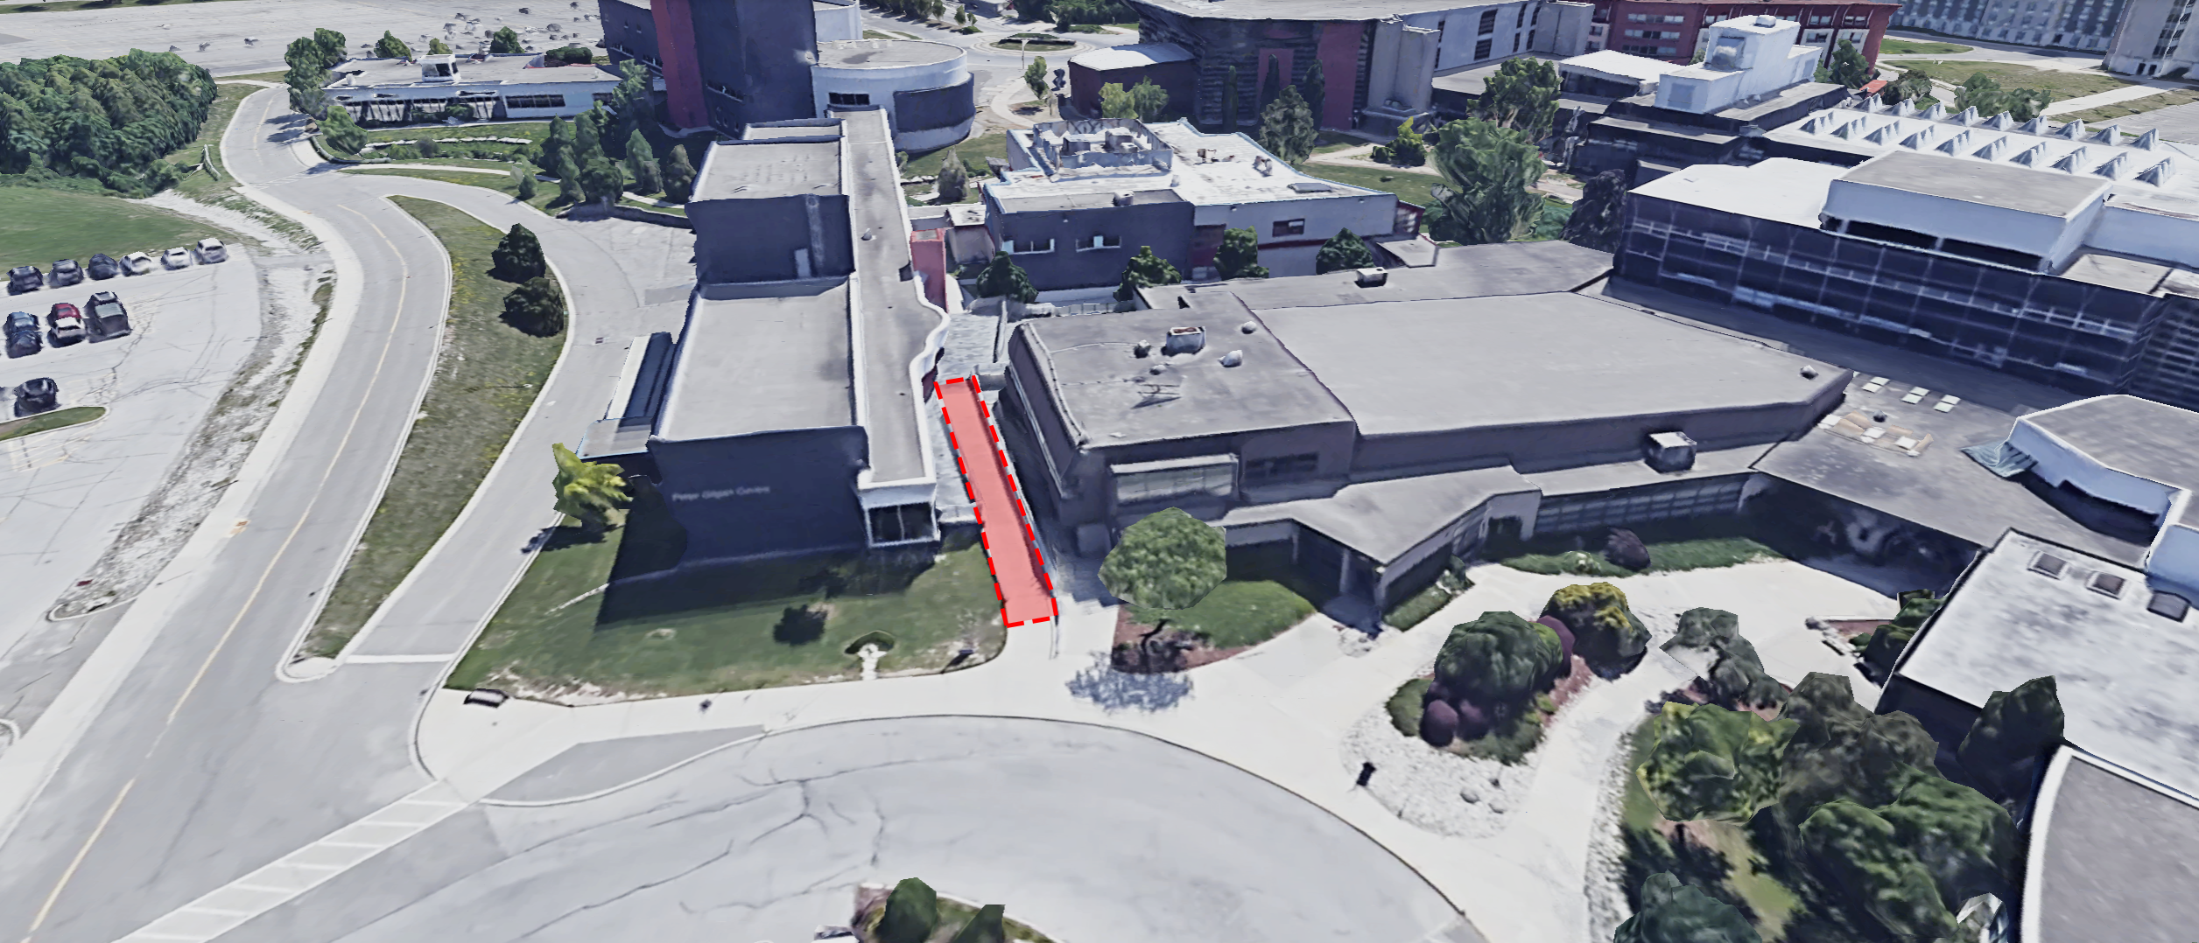

## Work Hours

Work will typically take place between 6:00am and 5:00pm from December 16th, 2024 through December 23rd, 2024.

## Disruptions

In order to complete the work effectively and in a safe manner, some restrictions will be necessary, including:

* Temporary closure for the week to pedestrian exterior walkway/Ramp between H-wing to D-wing

Alternate Route

Please use alternative routes to avoid the ramp. Alternative routes include, but are not limited to, the tunnel between the D-H wing (basement), the exterior pathway to and through the SSU, the exterior pathway to and through the SCAET/C-wing/E-wing/B-wing, and the J-Wing main entrance via the interbuilding bridgeway.

Sheridan College Facilities Projects looks forward to working with you to allow our Contractor to complete this project in a professional and timely manner. Every effort will be made to reduce any inconvenience you may encounter.

For more information, please contact [facilities@sheridancollege.ca](mailto:facilities@sheridancollege.ca)