Activity: Temporary Crane Activity and Pathway Closure
Project Title: B-wing Penthouse AHU Upgrade
Campus: TRA - Trafalgar Rd. Campus
Effective Date: Saturday, September 14, 2024

Trafalgar Campus Work Area Map and Alternative Accessible Routes

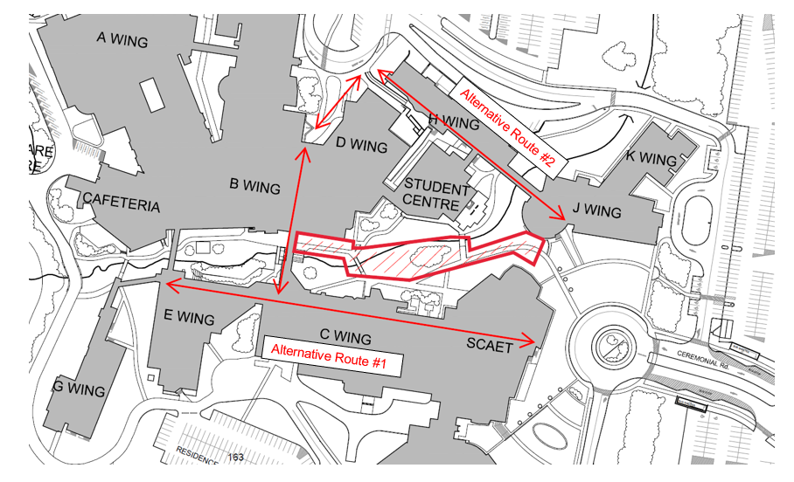
Alternative Route #2

Alternative Route #1

From SCAET/J-Wing:
Alternative Route #1:
- Enter SCAET main entrance
- Proceed through first or second level of SCAET following the C-wing wayfinding signage.
- Proceed into C-wing via first or second level and pass around the Learning Commons.
- Proceed to follow wayfinding signage to B-wing or E-wing to bypass the ‘work area’
Alternative Route #2:
- Enter J-Wing main entrance
- Proceed to follow wayfinding signage for H-wing
- Exit H-wing, proceed down the ramp towards the B-wing round-a-bout and main entrance to bypass the ‘work area’

From B-Wing:
Alternative Route #1:
- Proceed to follow wayfinding signage to C-wing
- Proceed through C-wing via first or second level and pass around the Learning Commons.
- Proceed through first or second level of C-wing following wayfinding signage for SCAET.
- Exit SCAET main entrance to bypass ‘work area’.
Alternative Route #2:
- Exit B-wing main entrance towards the round-a-bout and H-wing.
- Proceed up the ramp into H-wing.
- Proceed through H-wing following the wayfinding signage for J-wing.
- Exit J-wing main entrance to bypass ‘work area’

