Project Title: TRA Library Flood Remediation

Contractor: Winmar

Start Date: Tuesday, August 06, 2024

Scheduled Completion: August 09, 2024

Sheridan Facilities Projects, Facilities Services is currently engaged in asbestos remediation in the corridor C108 first floor C wing Trafalgar campus .During this time no access to the corridor will be permitted. Your co-operation and patience during the construction period is crucial and appreciated.

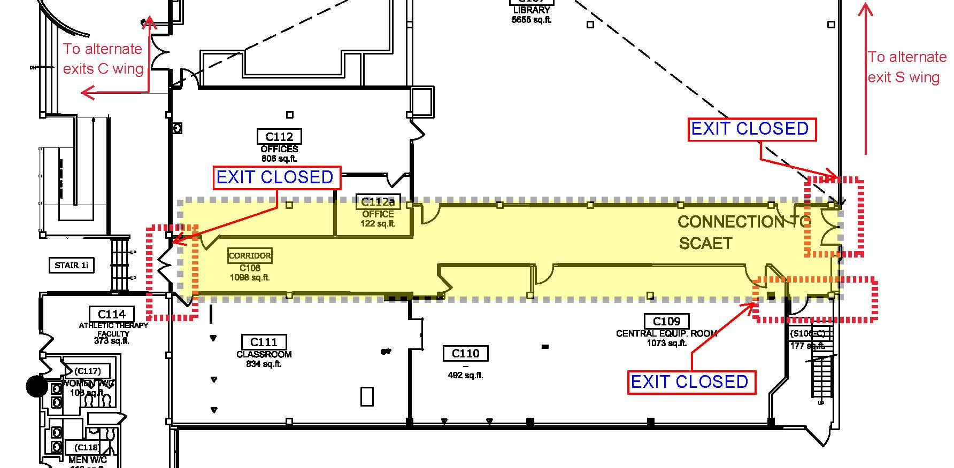

Work Hours

Work will typically take place between 7:00 a.m. to 5:00 p.m. from Monday to Friday and Weekends.

Disruptions

As with all construction projects, there will be noise and temporary inconveniences at times. In order to complete the work effectively and in a safe manner, some pedestrian restrictions will be necessary, including:

* Temporarily closed exits
* Under no circumstance enter the construction site.

Sheridan College Facilities Projects looks forward to working with you to allow our Contractor to complete this project in a professional and timely manner. Every effort will be made to reduce any inconvenience you may encounter.