Thursday, March 28, 2024

Project Title: Parking Lot #4 & Loading Dock – Sidewalk Repair
Campus: TRA - Trafalgar Rd. Campus
Contractor: Melrose Paving, MTE Consultants, Cyber Air Systems
Start Date: Monday, April 8, 2024
Anticipated Completion: Monday, April 15, 2024

The Work

Sheridan Facilities Projects, Facilities Services is working on the Rehabilitation of parking lot #4 and A-Wing shipping & Receiving roadway, including repairs to the sidewalk located outside the A3 Exit Doors.
Your co-operation and patience during the construction period is crucial and appreciated.

Map of Work Area

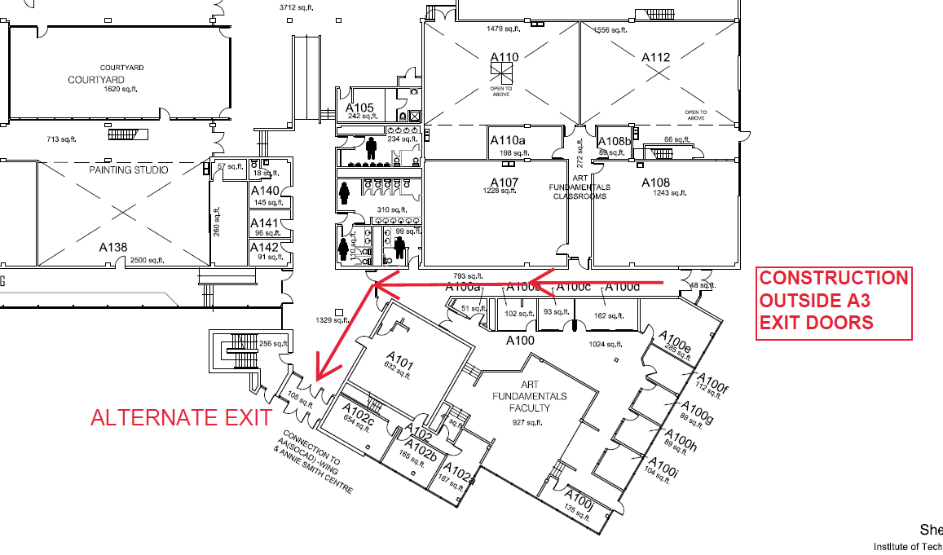
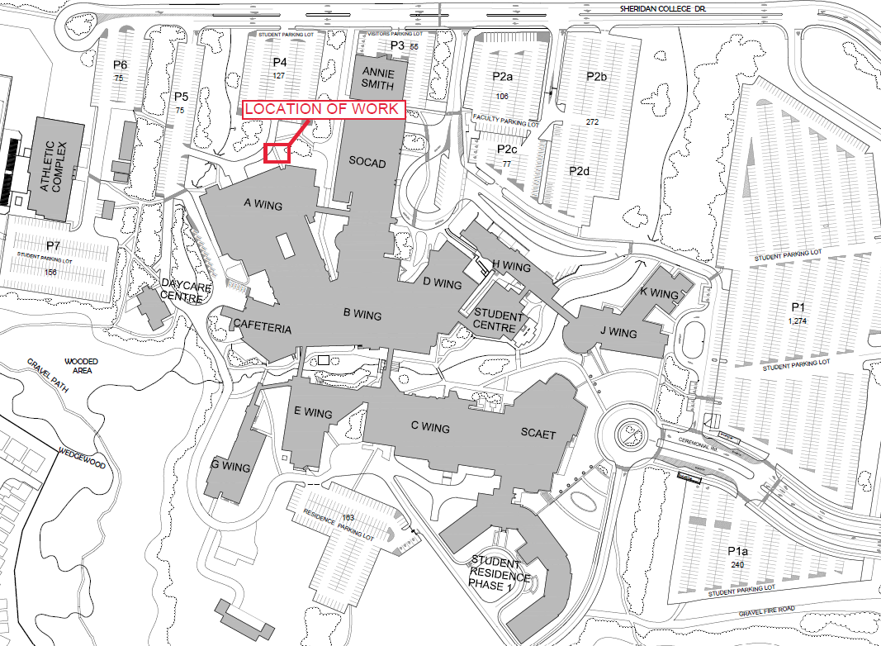

Work Hours

Work will typically take place between 8:00am to 5:00pm .

Disruptions

In order to complete the work effectively and in a safe manner, some restrictions will be necessary, including:
- The A3 Exit doors will remain open for emergency purposes only.
- The recommendation of taking an alternate exit route, avoiding the A3 Exit Doors due to construction.
- Potential physical barriers surrounding the work site located pathway outside the A3 Exit Doors
Sheridan College Facilities Projects looks forward to working with you to allow our Contractor to complete this project in a professional and timely manner. Every effort will be made to reduce any inconvenience you may encounter.

For more information please contact constructionfeedback@sheridancollege.ca

